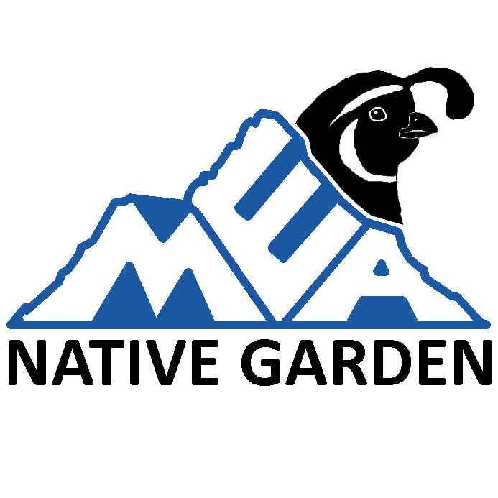
MASTER PLAN

Table of Contents
PREFACE 2
PURPOSE 3
Habitat for Wildlife and Plants 3
Benefits for the School Community 3
Sustainability 3
MAPS 4
Before 4
After 5
LOCATION AND SECTIONS 6
The North Section 6
The South Section 6
PHASE 1: PLANTS 6
Hose Line or Irrigation 6
Mulch 7
Planting Map 7
Plant List 7
Planting Events 8
Protecting the Plants 8
PHASE 2: INFORMATION, SIGNS, AND MORE 8
Benches 8
Path 9
Garden Sign 9
Plant species signs 9
Bird Checklists 9
PHASE 3: EDUCATION 9
Wildlife Journalism 9
Special Guests 9
Part of the Curriculum 10
FUNDING AND DONATIONS 10
Donations to School for the MEA Native Garden Project 10
Grants 10
Discounts 10
FUTURE ADDITIONS: NEST BOXES & WILDLIFE HIDE 10
Owl Nest Box 10
Bird Nest Boxes and Platforms 10
Wildlife Hide Fence 11
Wildlife Hide Observatory 11

PREFACE
The Mt. Everest Academy Native Garden will be a natural, outdoor area on the K-12 school campus to educate students and provide habitat for wildlife.

PURPOSE

Habitat for Wildlife and Plants
The garden will become home to various native plant species. These plants will jointly create a mix of chaparral and coastal sage scrub ecosystems, which also occupy the nearby Tecolote Canyon and support native wildlife. Once established, the plants will attract a variety of local and migratory wildlife including Monarch butterflies, Towhees, flycatchers, and possibly the threatened Coastal California Gnatcatchers. The garden may then be considered a wildlife habitat, adding to the nature within the City of San Diego.

Benefits for the School Community
The garden will have signs and educational resources for visitors of Mt. Everest Academy to learn about nature. The garden will provide a unique opportunity to connect to and learn about various aspects of the natural world. As an outdoor classroom, it can be a useful tool to teach subjects such as biology. Students can learn about the coastal sage scrub and chaparral ecosystems of San Diego. They will learn about the life cycle of butterflies. Sometimes the elementary students raise Monarch butterflies, so the school garden can potentially be a place to release or even raise the butterflies.
Teachers may be instructed on how to teach students to create scientific wildlife field journals. These journals would allow students of all ages to learn how to properly observe nature more in depth than before. They can learn to make and write their observations in a scientific matter and may even make their own scientific discoveries. As part of these journals, students can note the species of birds they observe, and later, these observations can be entered into Ebird, providing data about bird populations and species.
Students will be able to connect with nature and develop a lifelong appreciation for nature. Spending time in nature also improves mental health and provides many other health benefits. Visitors will have a better understanding of the local ecosystems in San Diego. They will learn to apply their knowledge of plants and wildlife throughout San Diego and may be inspired to create their own native plant garden at home.

Sustainability
The garden will be water wise, only requiring watering for the first 2 years until the plants are established.

MAPS

Before
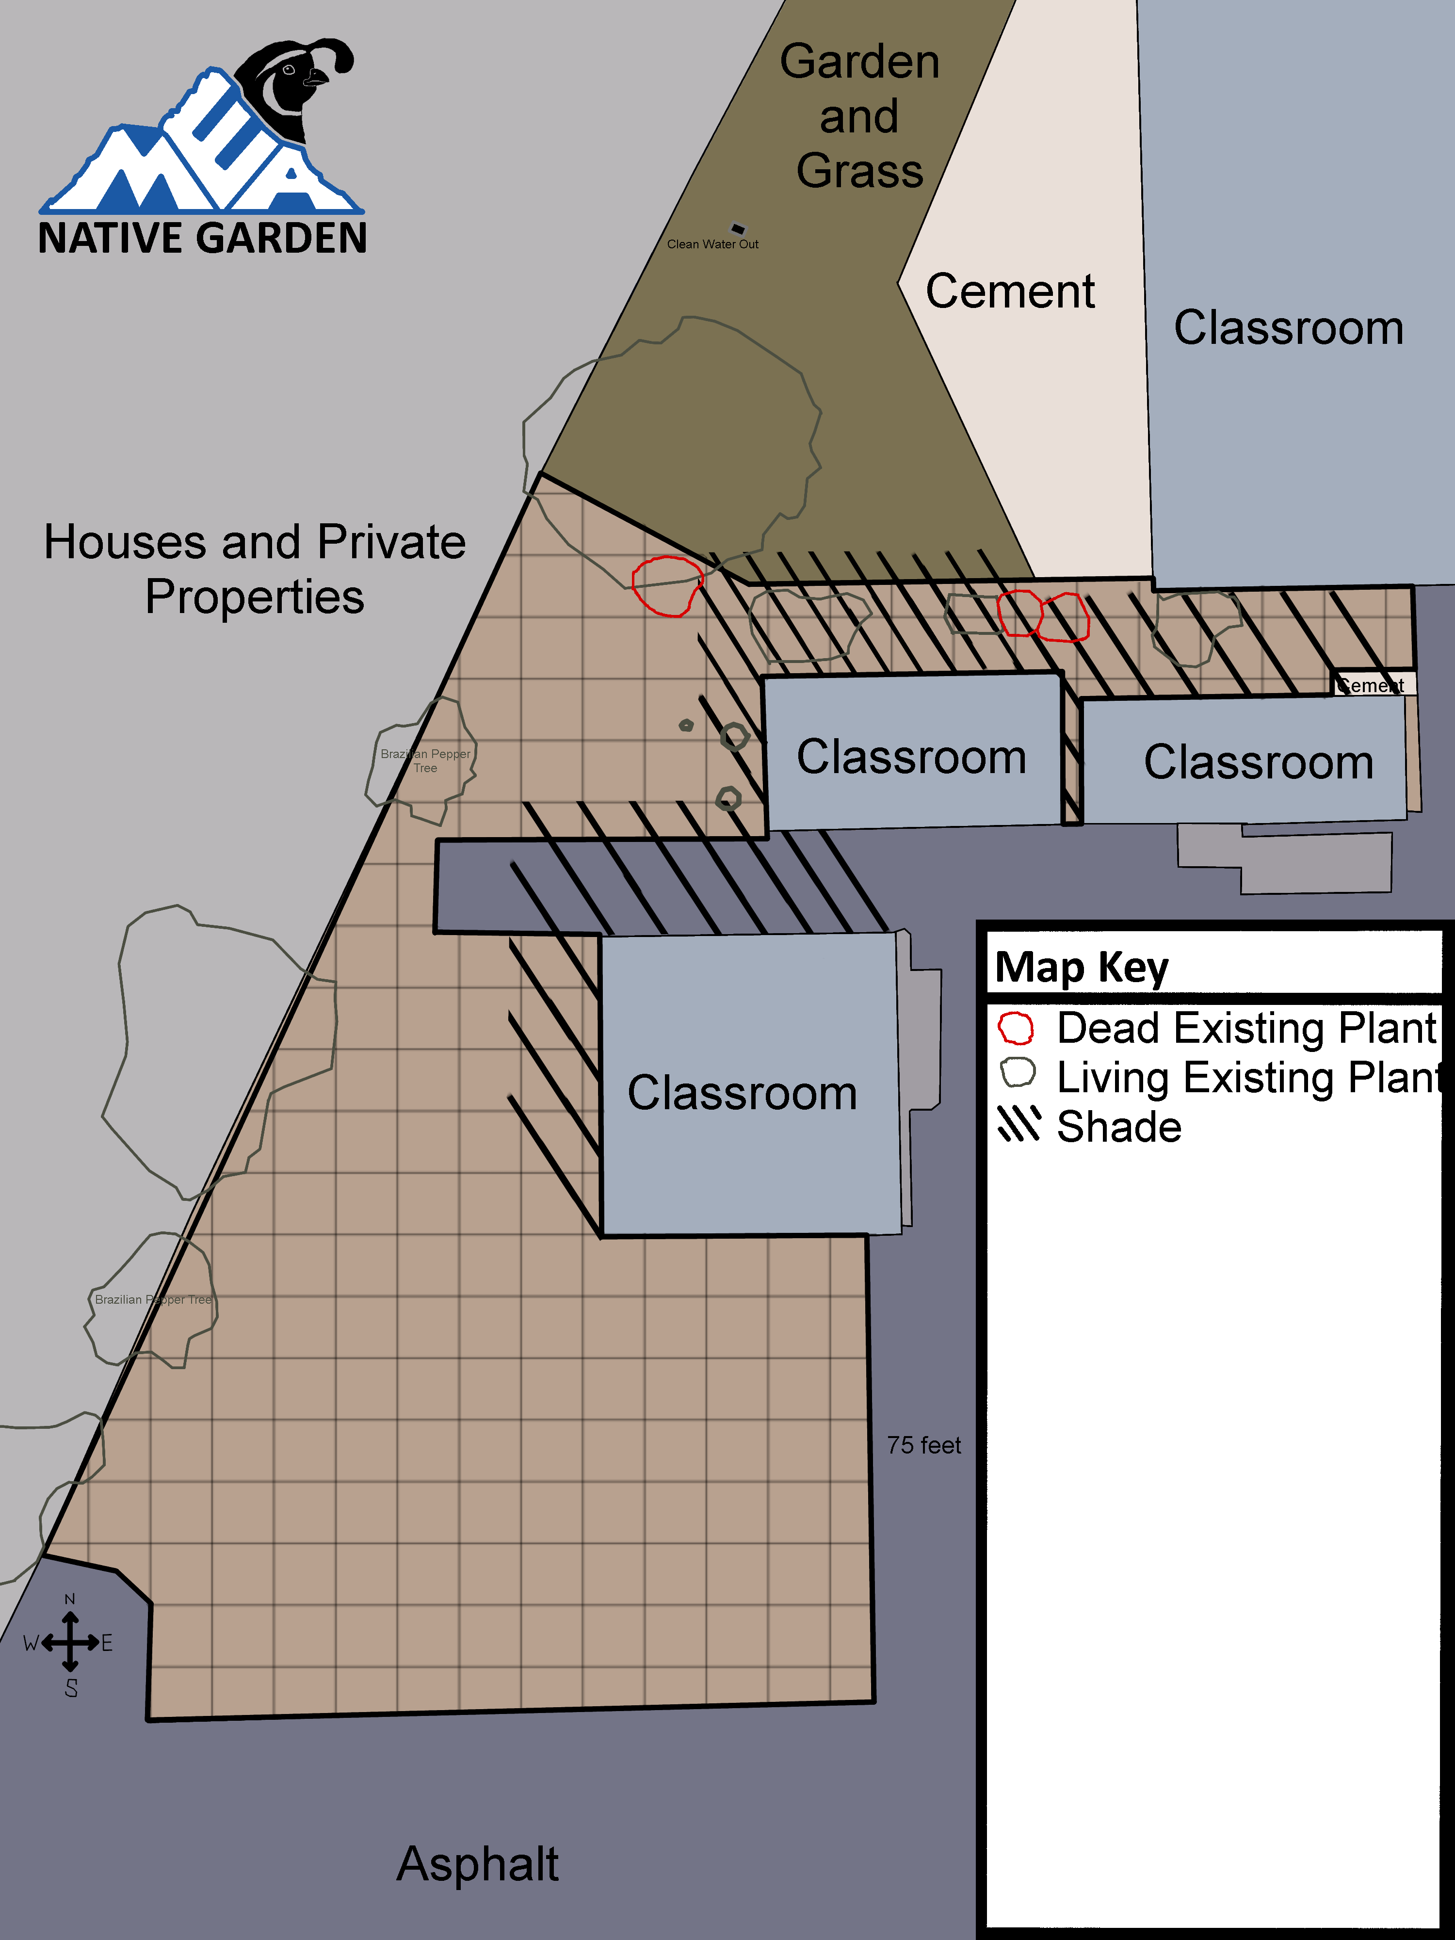

After
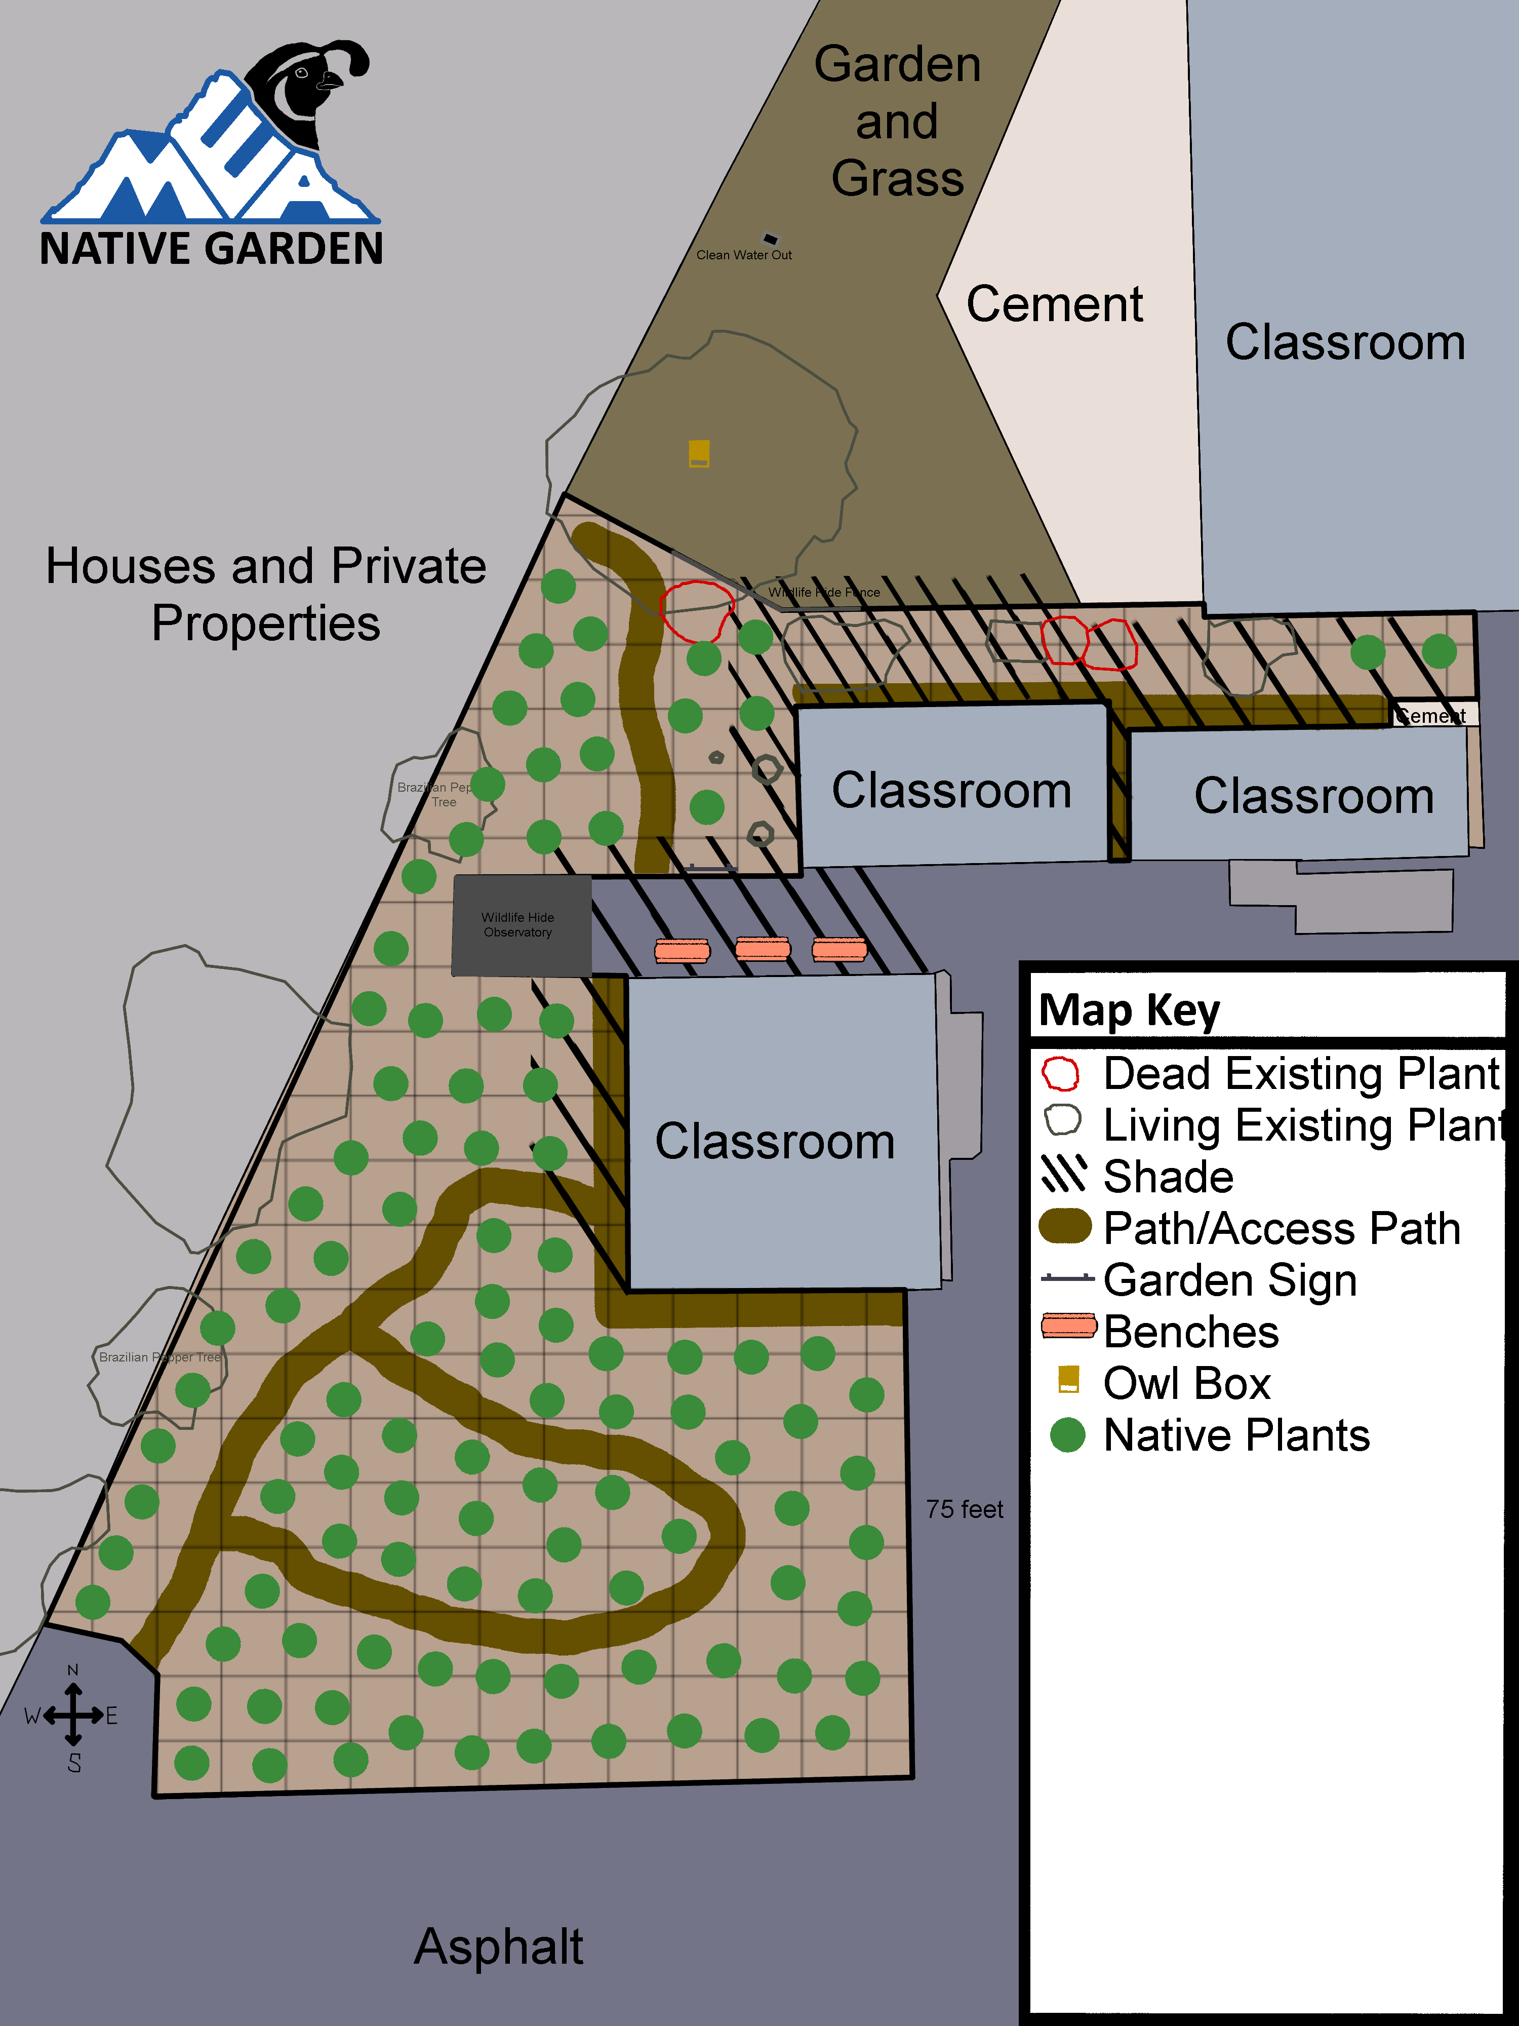

LOCATION AND SECTIONS
The garden will be located at the West end of the Mt. Everest Academy campus and is separated into two sections. The garden area borders houses and private properties and is encircled by asphalt and classrooms. It is also located in the vicinity of the school agricultural garden. The total area of the garden space is approximately 0.4 acres or 17,300 square feet. The planting area is flat with no slopes. For more information, see the image of the map.

The North Section
This section is smaller and closest to irrigation. There are already a few native plant species and small trees growing in this area, so planting may begin whenever a hose line or irrigation is provided and plants are purchased. There is an invasive Brazilian pepper tree in this section. When the budget allows, this tree will be removed. Otherwise, no planting will be done right next to the Brazilian pepper tree.

The South Section
This section is larger and farther from irrigation. There are two native plant species that grew without any external help, but later died. It is uncertain whether plants will survive, although with additional watering and mulch covering, it is likely no soil amendment will be necessary. After planting in the North section is completed, a few natives may be planted in this section. If the plants seem to be surviving well, the section can be completed with additional planting. There is also an invasive Brazilian pepper tree in this section that should be removed eventually.

PHASE 1: PLANTS

Hose Line or Irrigation
If possible, a hose line would be the least expensive option (possibly free) and an effective way to provide water to the native plant garden. Planting would then be able to begin February-March 2022. If this is not possible, manually transporting water to the garden (labor intensive) would also be an option to allow planting this February-March 2022. Otherwise, an underground irrigation line would be needed. This option is expensive (Up to $2,000) and would not be finished in time and planting would have to wait until next winter of 2022-2023. Although it is a permanent solution to providing water to the garden, the garden will only require regular watering for 2 years. After that, additional water is only needed if plants seem to be struggling during the hot summer months. Therefore, the price of the underground irrigation line will only delay the project. The underground irrigation could also be added later on, so it is more important to provide water in another form soon.
Watering cans on a cart will be transported to the plants every week to water them, and planting will begin February-March.

Mulch
Mulch would be useful to surround each plant and increase the chance of plant survival. Pine, oak, or redwood mulch mixed with boulders or large rocks can be used. (https://www.lowes.com/pd/Garden-Time-2-cu-ft-Brown-Garden-Bark/3731889)

Planting Map
This is a map of where each plant will go in the garden. Planting will begin in the North Section February-April 2022, and the majority of the South Section planting (besides the test subject plants) will occur in the winter of 2022-2023.

Plant List
Funds from grants and donations will be used to buy plants (besides the initial costs of irrigation preparation). The amount of money received will decide the number of plants purchased. When enough funding is provided to buy plants ($40-$100 for 5-13 plants discounted price from Native West Nursery is $40-$100 for 10-25 plants), the first round of plants will be bought.
CHA: Chapparal
CSS: Coastal Sage Scrub
(Flower): Flowering season
First Round of purchasing plants: 20 plants total, cost: $80-$100 for plants.
Mulch needed: 10 bags for 20 plants total for $46.80 at Lowes.
Watering Cans: 4 for total for $24 (https://www.lowes.com/pd/Misco-Home-and-Garden-2-Gallon-Watering-Can/5001941459).
Total Cost of round one planting: about $160
NAME OF PLANT | (CHA or CSS)  (Flower) | MORE INFO | MATURE (HEIGHT)(WIDTH) | NUMBER OF PLANTS | POT SIZE | TOTAL COST
Broom Baccharis  (Baccharis sarothroides) | CSS | Very attractive to insects, small birds eat the seeds | 3 - 12 ft tall  6 ft wide | 2 | 1 gal
Coyote Bush  (Baccharis pilularis) | CSS | Very attractive to insects | 1.5 - 10 ft tall  12 ft wide | 2 | 1 gal
California Sagebrush  (Artemisia californica) | CSS | California Gnatcatcher, Quail, various other birds, insects | 1 - 8 ft tall  4 ft wide | 4 | 1 gal
Black Sage  (Salvia mellifera) | CSS | Insects and hummingbirds are attracted to the flowers. Quail, Towhees and other birds are attracted to the seeds. | 3 - 6 ft tall  10 ft wide | 4 | 1 gal
White Sage  (Salvia apiana) | CSS |  |  | 4 | 1 gal
Cleveland Sage  (Salvia clevelandii) | CSS |  |  |  | 1 gal
Toyon  (Heteromeles arbutifolia) | CHA |  |  | 2 | 1 gal
Lemonade Berry  (Rhus integrifolia) | CHA |  |  | 2 | 1 gal
Laurel Sumac  (Malosma laurina) | CHA |  |  |  | 1 gal
Mission Manzanita  (Xylococcus bicolor) | CHA |  |  |  | 1 gal
Deergrass  (Muhlenbergia rigens) |  |  |  |  | 1 gal
Narrow Leaf Milkweed  (Asclepias fascicularis) | (Summer, Fall) | Monarch Butterflies | 1.7 - 3.3 ft tall  1 ft wide |  | Seeds
Chamise  (Adenostoma fasciculatum) | CSS |  |  |  | 1 gal
California Fuchsia  (Epilobium canum) |  |  |  |  | 1 gal
Coffeeberry  (Frangula californica) | CHA |  |  |  | 1 gal

Planting Events
All MEA students and staff will be invited to come to the planting events. Before the first round of plants is purchased (when there is enough funding to buy the plants), an event will be organized to dig holes in the designated area. These holes will be deep watered in preparation for planting. When the first round of plants is bought, an event will be organized to plant these plants in the designated holes. At this event, students and teachers will be invited to help plant and water the garden. Planting or hole digging events can also occur during class time for younger students.

Protecting the Plants
Signs and caution tape or something similar can be placed to make sure students don’t accidentally damage the plants. Wildlife is unlikely to damage the plants because the wildlife found in this area is mostly birds and lizards. In addition, the plants are native, so they are designed to support the local wildlife without being severely damaged by it.

PHASE 2: INFORMATION, SIGNS, AND MORE

Benches
School benches will be placed on the asphalt between the two classrooms where there is full shade for the majority of the school day.

Path
A flat dirt path will allow students to walk through the garden and enjoy the plants.

Garden Sign
A large garden sign will have the name of the garden with names of donors listed. It can be a kiosk with information on wildlife and plants in the garden for visitors to read. It can also have pamphlets or small booklets for visitors to read as they walk through the garden. It can also be a scout project if anyone is interested in creating it for the school.

Plant species signs
Small signs will be placed next to each plant bordering the garden path. These signs will include names of plants (both scientific and common) and can be created by students in the maker space or purchased if budget allows.

Bird Checklists
Bird checklists for visitors to fill out can be created, either physically or online or both. These will allow students to actively identify bird species in the garden. These checklists can be collected (maybe in a box at the kiosk) and submitted into Ebird, providing important data on the bird population.

PHASE 3: EDUCATION

Wildlife Journalism
Instructions on taking wildlife field notes can be provided by specific books in the library or as a simple guide on the garden sign. Extra journals from the school can be given to students to use for writing nature observations or simply artistically writing or drawing nature.
Additionally, there can be events a few times a year, when wildlife journalism is taught by an MEA teacher or a special guest.

Special Guests
Guest speakers can be invited to educate students on nature. These include Audubon Society, San Diego Humane Society Project Wildlife, and Native American cultural leaders. The MEA community can then learn more about birds, wildlife rehabilitation, native plant use for food and medicine, and more.

Part of the Curriculum
Especially in the elementary level and for biology classes, the MEA Native Garden can be used to aid teaching students. An outdoor classroom has many benefits, so learning in the garden should be incorporated into the curriculum. Ideas for incorporating the garden for teaching include growing native plants from seeds, performing scientific studies, studying the life cycle of butterflies, learning about the ecosystem, and more.

FUNDING AND DONATIONS

Donations to School for the MEA Native Garden Project
Families and friends may donate to the school and address the donations for the “MEA Native Garden Project”. They may choose if they want their name listed on the project website and Garden Sign or not. We will also send community letters to potential donors

Grants
We will apply for the San Diego Native Plant Society’s Mini Grants (up to $500).
Kids Gardening – GroMoreGood Grassroots Grant – February 4^{th.}

Discounts
We will contact the plant nurseries to ask for discounts on plants.
We will contact plant nurseries or garden supply store for donations or discounts on mulch.

FUTURE ADDITIONS: NEST BOXES & WILDLIFE HIDE

Owl Nest Box
An owl nest box can potentially be added to the large pine tree right outside the edge of the garden. The owl nest box can include a camera to allow students to study or watch the owls raise their young (assuming owls would nest in the box). Students can learn about the damaging effects of rat poison towards owls. If owls are regular visitors, there is also a very large chance that there will be owl pellets on the ground. These can be used to dissect for school projects.

Bird Nest Boxes and Platforms
Nest boxes for smaller birds can potentially be added in the garden. They may also have cameras to allow for viewing without disturbing the wildlife. Nesting platforms can be added to nearby classroom buildings near windows so students can watch the bird nests without disturbing wildlife. For nests near windows, stickers of some type would be added to protect birds from fatally crashing into the windows.

Wildlife Hide Fence
The fence bordering the native garden and agricultural garden can be used to create a simple wildlife hide. By entering wood strips or attaching pieces of wood to the fence, a wildlife hide wall can be created. Students can also peak through the gaps in the wall to watch wildlife without significantly disturbing it. Benches may also be added to allow students to sit as they watch.

Wildlife Hide Observatory
The Wildlife Observatory structure could be a small, enclosed natural-themed building placed on top of the asphalt dividing the North and South Sections. This structure could contain multiple viewing areas including one-way viewing glass (possibly also below ground), a nest box (with a glass back visible from inside the wildlife hide), an artificial burrow (with one-way viewing material), and windows with curtains (open to be used for wildlife photography or simply viewing). Cameras could also be added to record any nighttime visitors. This structure could be used for wildlife journalism, studying, teaching, and more.

